**Need finding assignment**

**Commuting Discipline**

We observed that most commuters choose to ride the jeepney in an undisciplined way because they don’t want to fall in line in the terminals because the line is too long and they are sometimes in a hurry. It can also cause traffic especially when jeepney drivers stopped in the middle of the road and let commuters in.

**User Observation**

* What are your experiences when commuting during rush hour?
* Do you fall in line on jeepney terminals?
* Is it faster to get a ride when you’re not in the terminal?
* Do you still fall in line on terminals even though you’re late? Or you choose to ride jeepneys on the illegal loading area?

**#1** Nathaniel Alzate, a student at University of Makati and currently taking an Information technology course. He usually ride jeepneys when going to school and at work because he is a working student. As a commuter he sometimes ride jeepneys in the illegal loading areas but sometimes he also fall in line on terminals to ride a jeepney.

**v**

**#3** Christian Barraceros, a student of Rizal Technological University and currently taking Computer Engineering. He usually ride jeepneys when going school and home. As a commuter he has also a hard time when riding a jeep especially in rush hour and always riding in the illegal loading areas because he’s always in hurry.

**PHOTOS:**

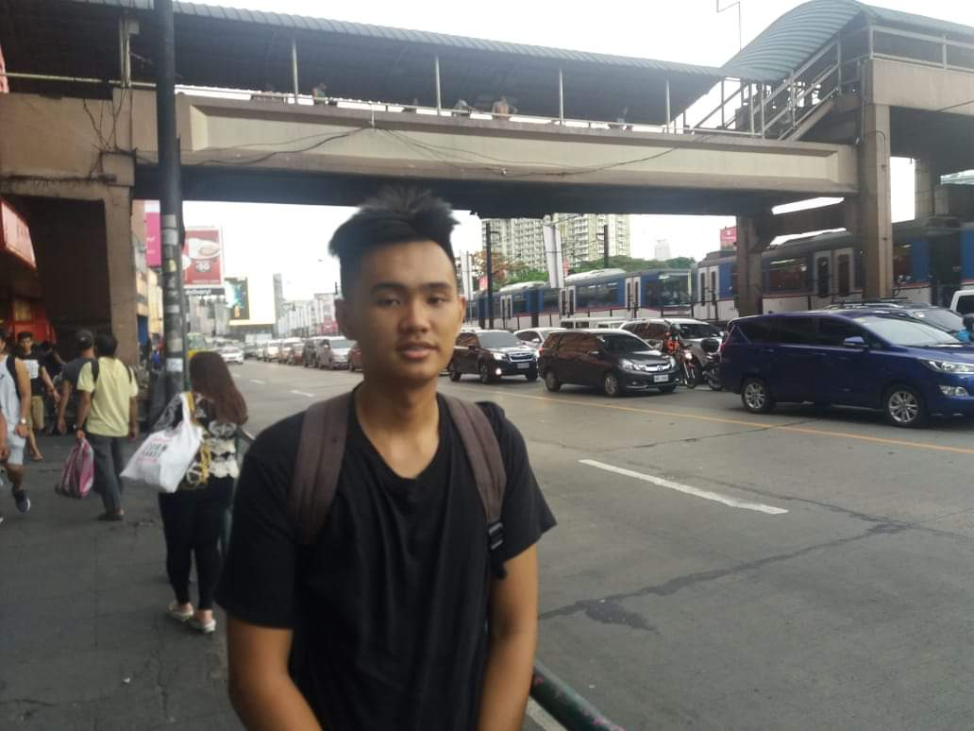

**User needs:**

* Disciplined jeepney drivers
* Commuters should think that it can cause traffic and accidents
* Every terminals should have MMDA’s
* Terminals should have many jeepney and drivers so that they will get a ride faster.
* Every PUV’s that are loading commuters that are not in the loading area will receive a serious violation.
* Make the road violations more strict.

**Need finding Talk**

* What activity did you choose to examine?
* The activity that we chose to examine is the commuters that ride PUV’s everyday and what they usualy do when they are commuting., if they are disciplined or not.
* How did you examine it, with what methods?
* We examined it through experience because when im a senior high school student I usually ride jeepneys and see jeepney terminals. My partner is also living near the jeepney terminal.
* What major insights or breakdowns did you discover?
* We noticed that some commuters are not disciplined in the road especially when riding PUV’s and these causes many traffic problems.
* What promising unmet needs were identified as a result?
* The needs that we identified is lack of disciplined commuters and drivers. These can also be the causes of traffic problems and accidents in the road.